**Aim:** To understand AWS Lambda, its workflow, various functions and create your first Lambda function.

**Steps With Screenshots:**

* Login to your AWS Management Console sign is as a root user.

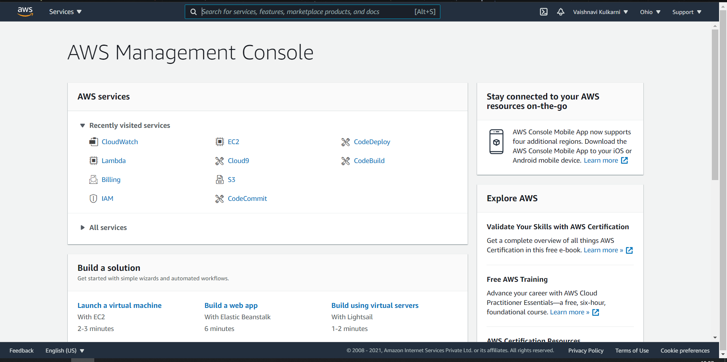

* In Services search for LAMBDA service and select it you will see the below screen

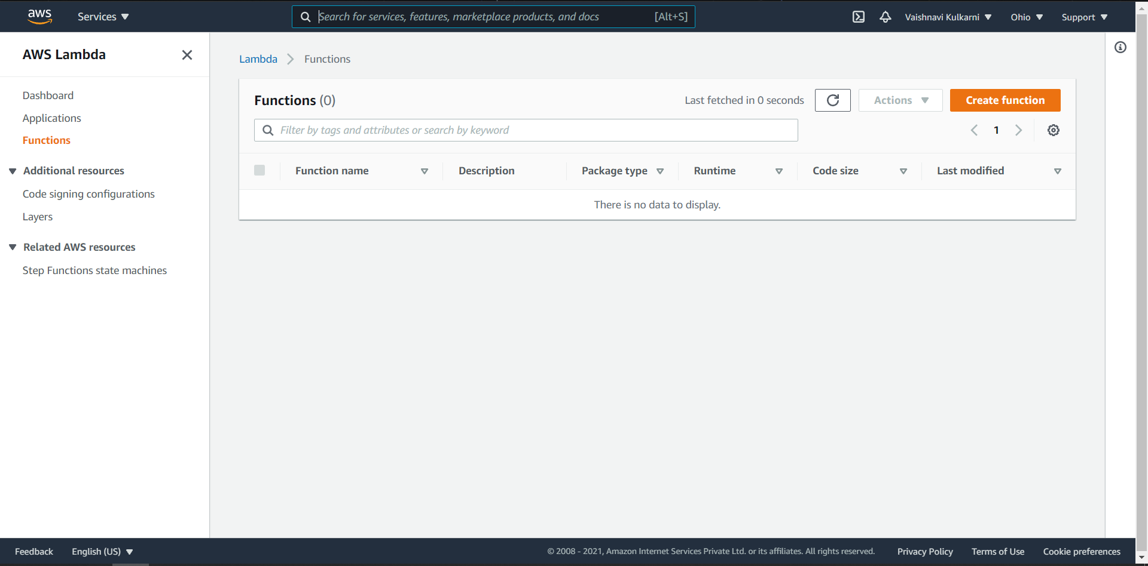

* Click On Create Function button and then type any name **(“expt7-function-vk”)** of your function and select a runtime environment of your wish in which environment you want to create function. Here I have selected default runtime environment.
* Then Click on Create Function button.

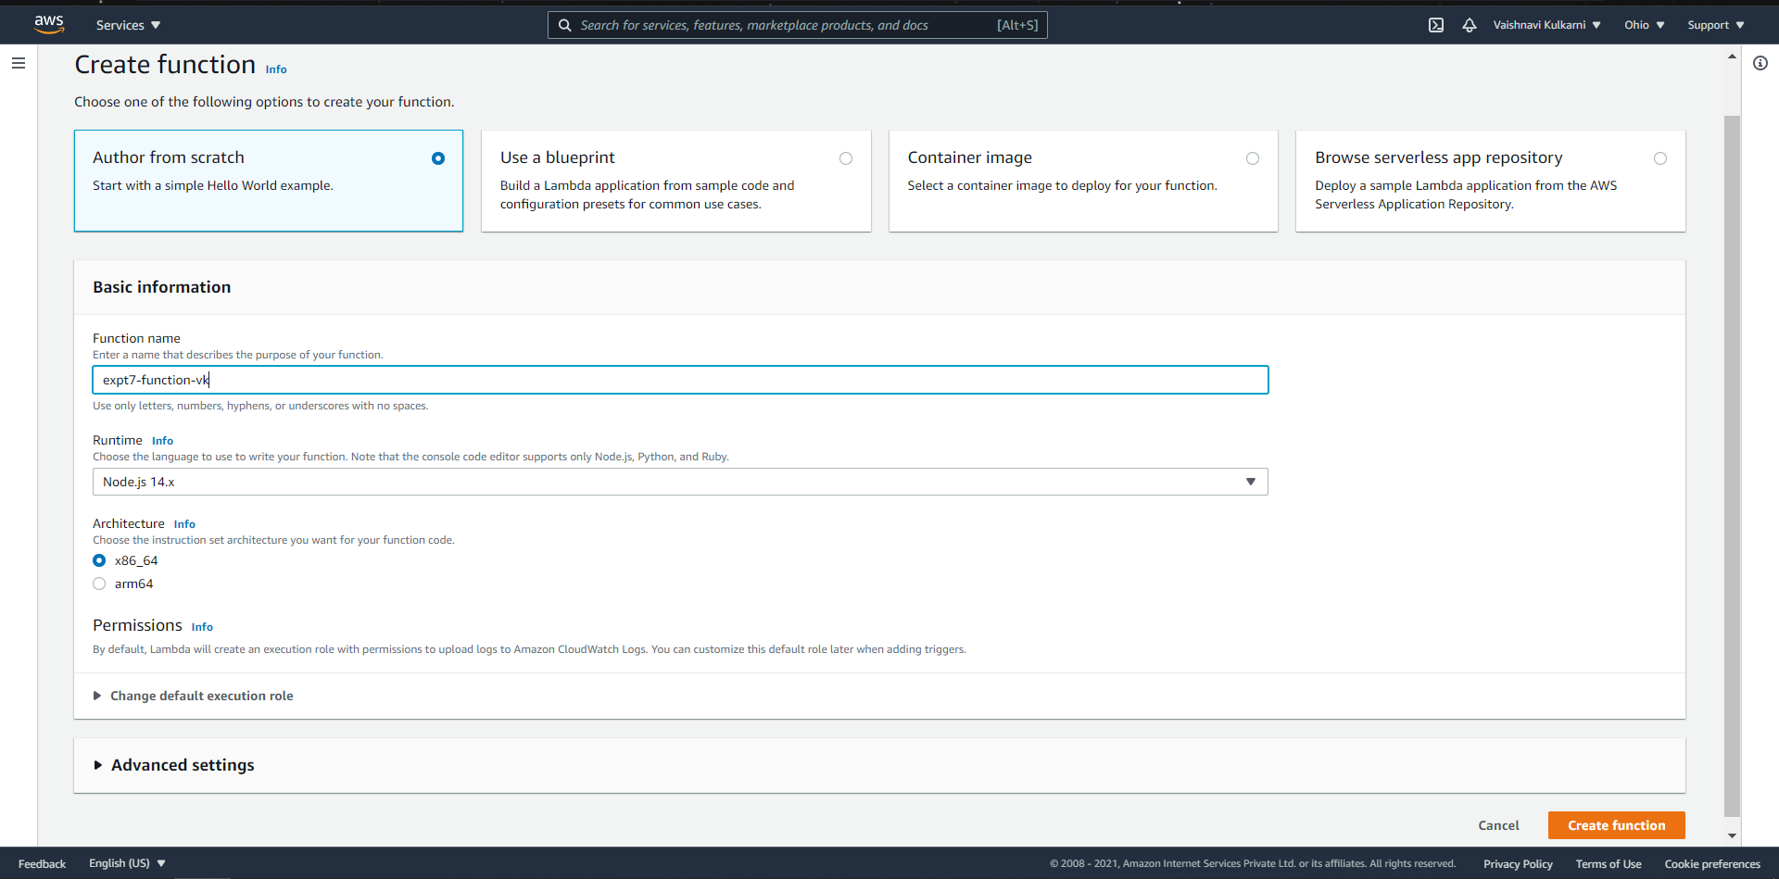

* Now we can see under functions tab our Nodejs function is created successfully.

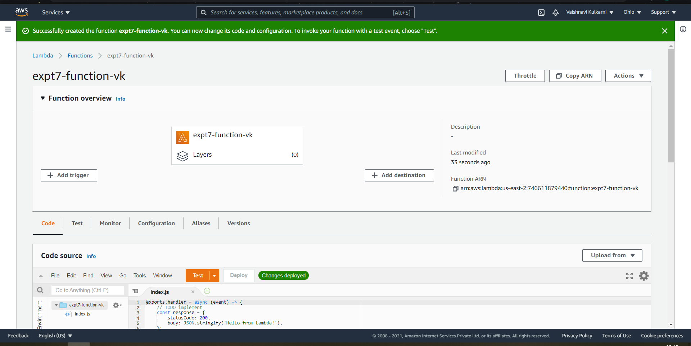

* After successfully creation of our function, we are now going to select “test” tab from the code section below

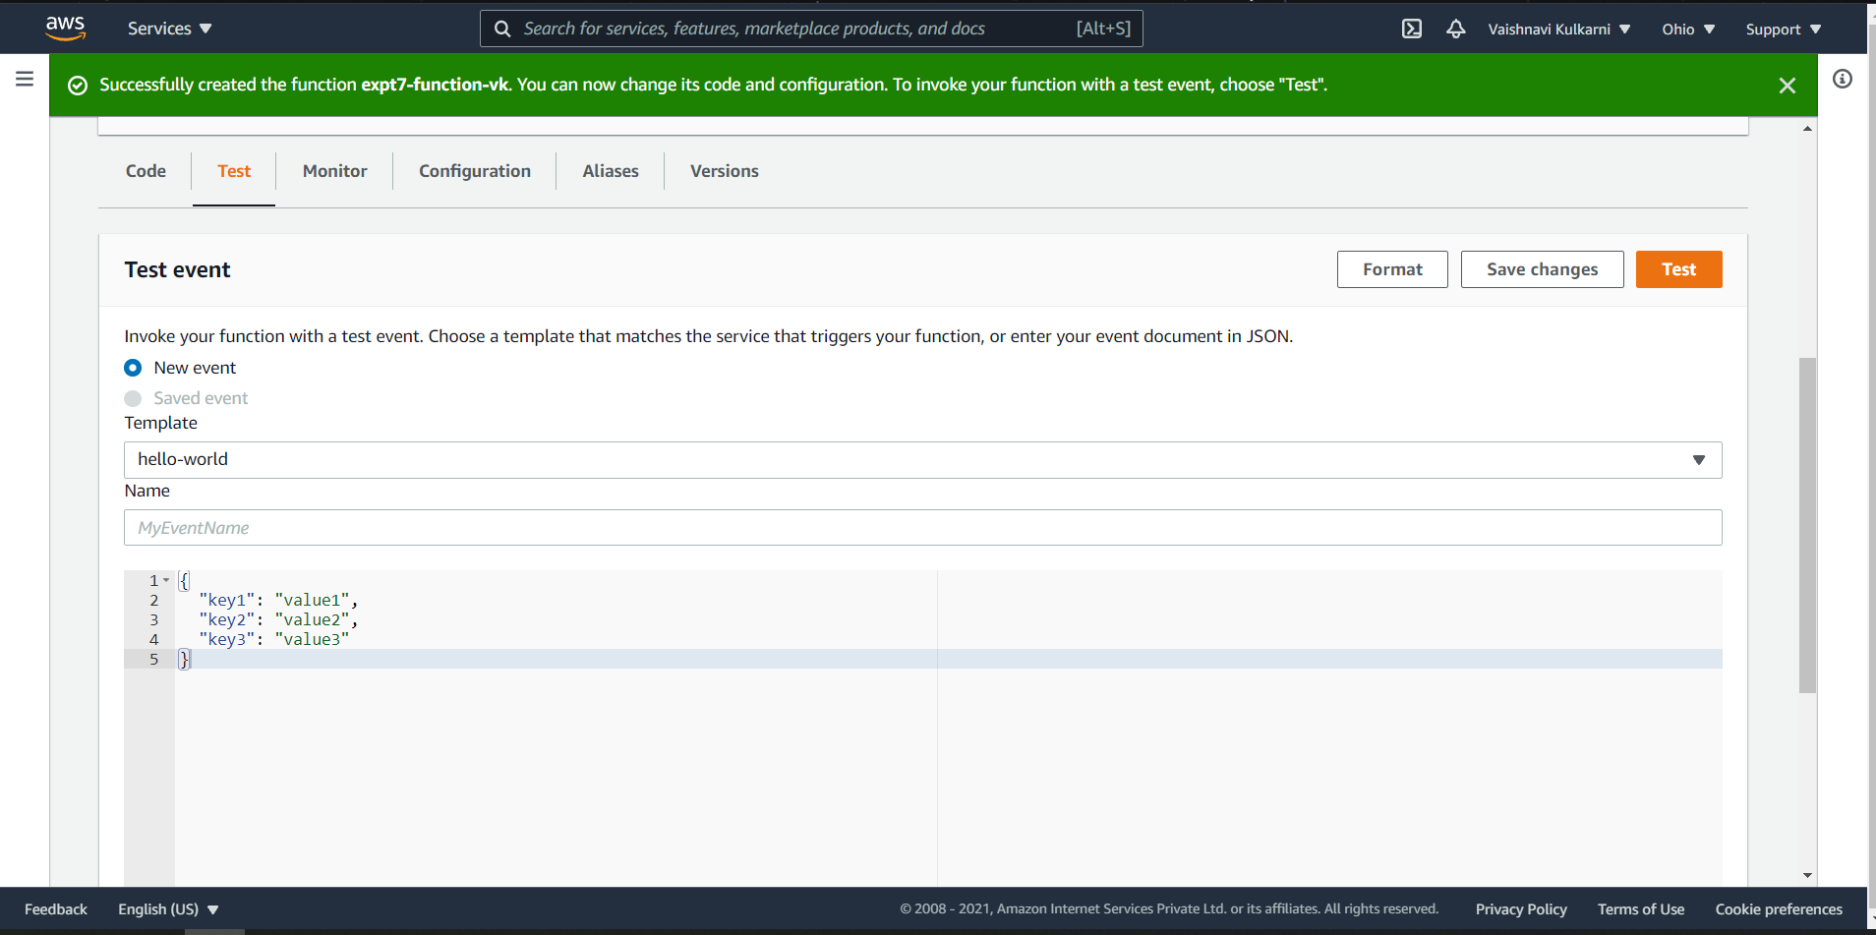

* After selecting test tab we will enter the name of the event **(“myeventvk”)** and then click on save changes button.

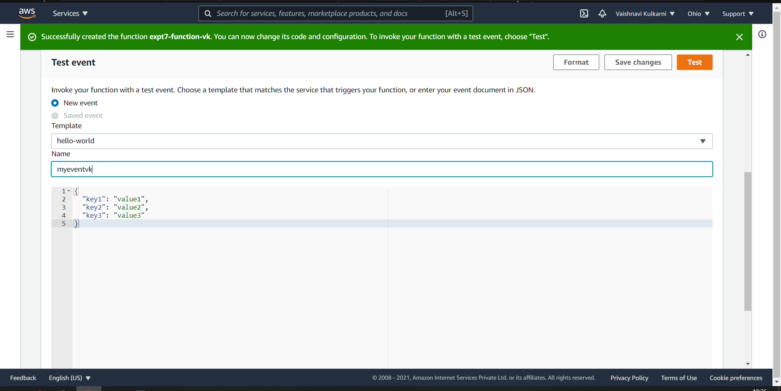

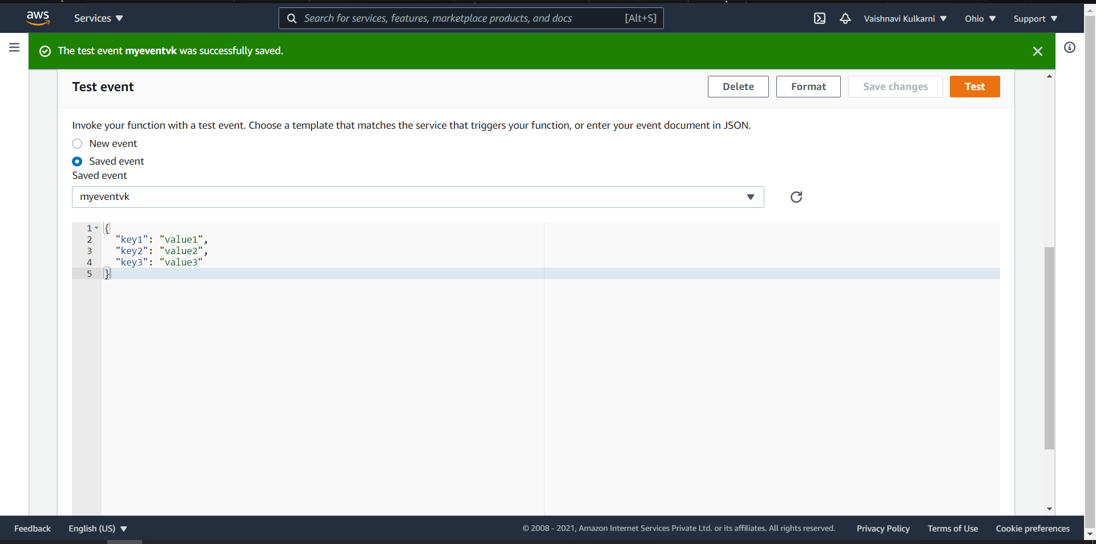

* After clicking on save changes button our changes in that event are saved now, we will click on test button to test this particular function.

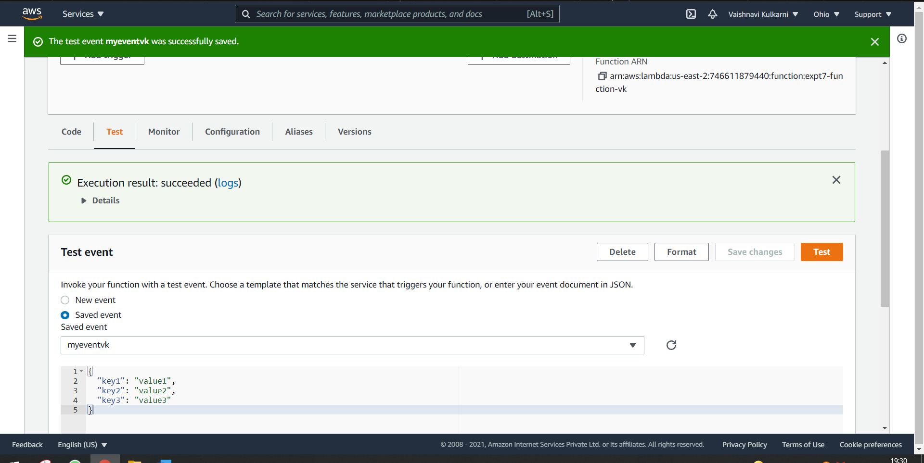

We can see that execution result: succeeded after clicking test button.

* If we want to see function execution result, we can click on details option.

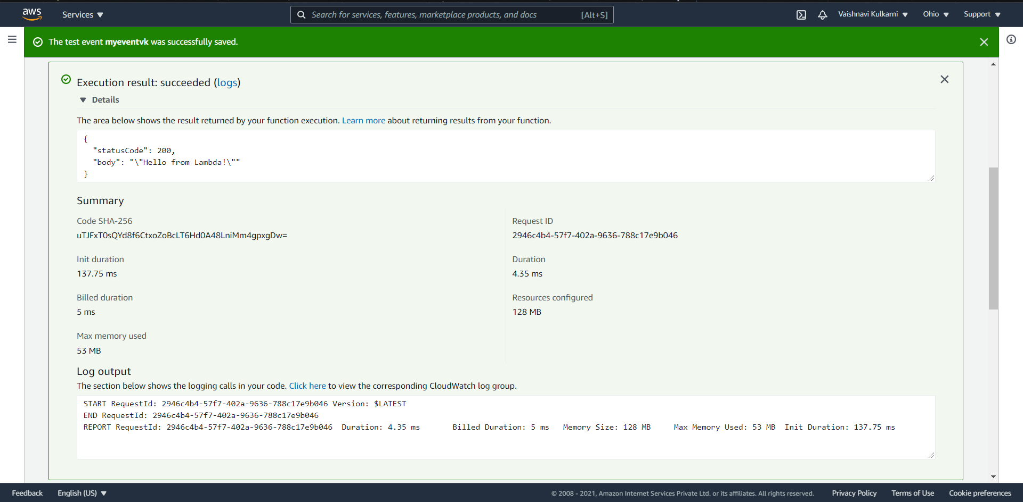

* If you want you can see the logs of this function by clicking logs link which will redirect you to CloudWatch AWS Management console which will contain more information about our created function.

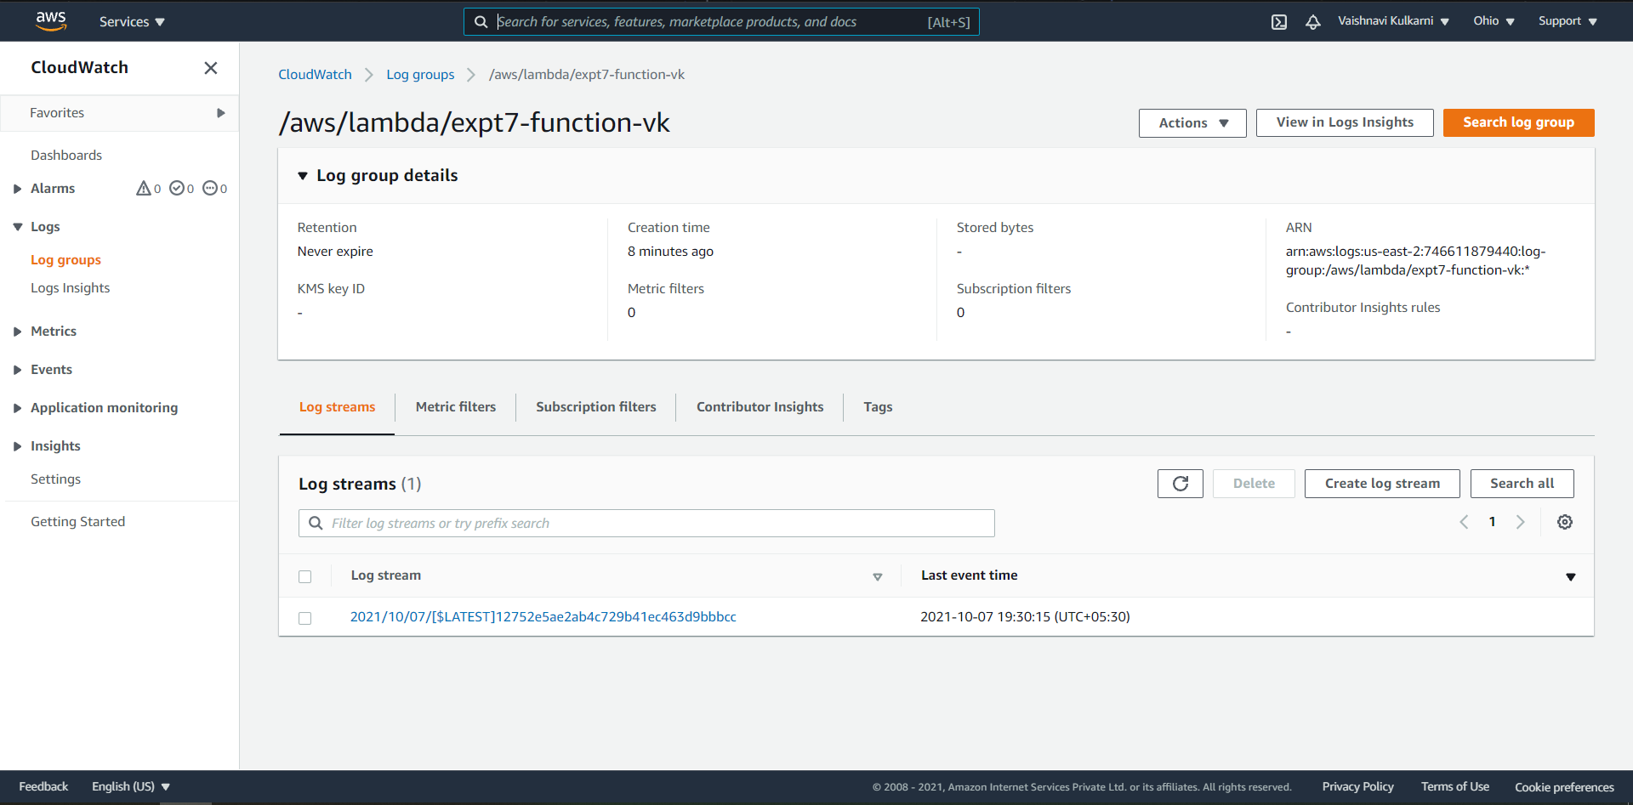

In one lambda function we can test 10 different events

* You can also select the monitor tab which will show the graph related to matrix and which lambda function sends to cloud watch we can also see that, also we can see invocations, durations, and error count in the form of graph.

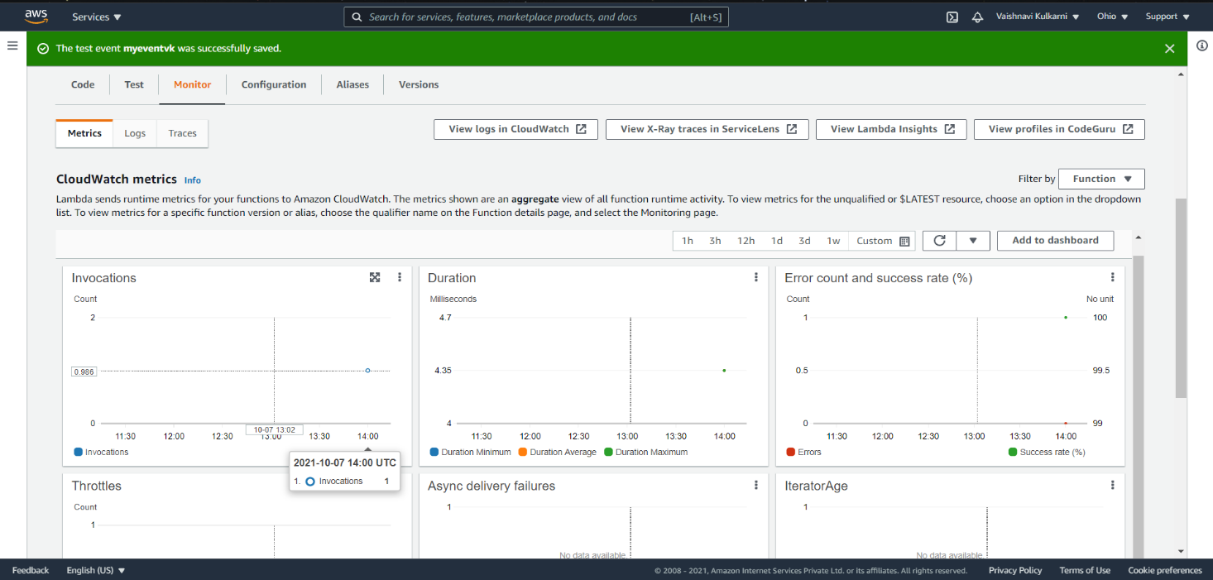

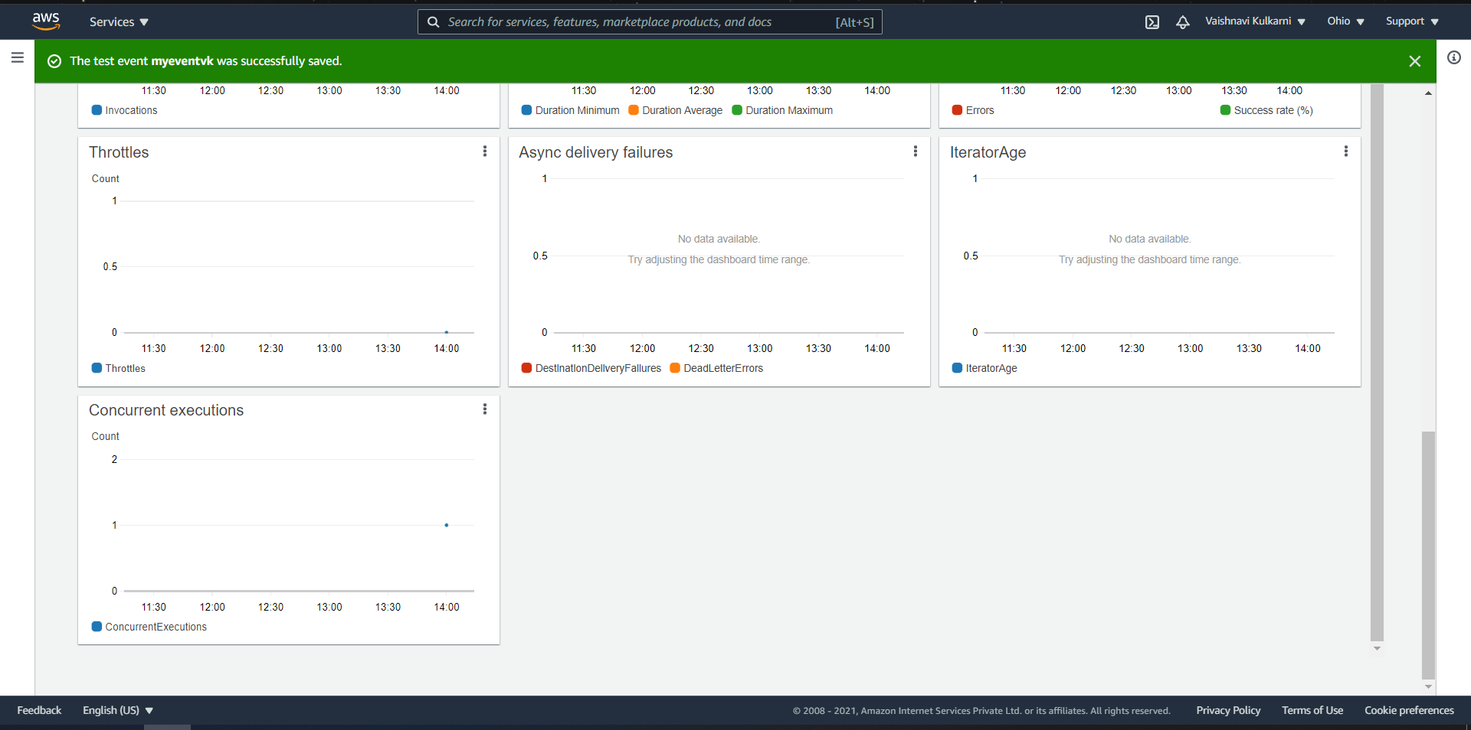

* Also, you can delete the function which you created.
* For that go to function console and select the function you wish to delete and then select actions tab, then click on delete button

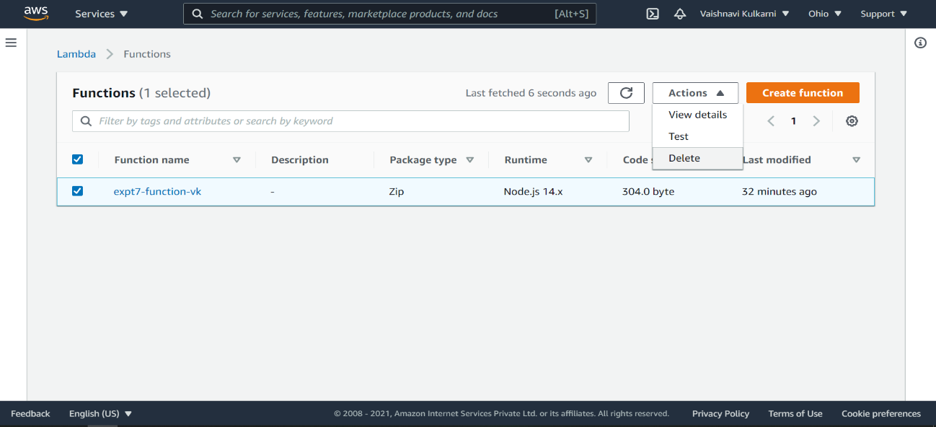

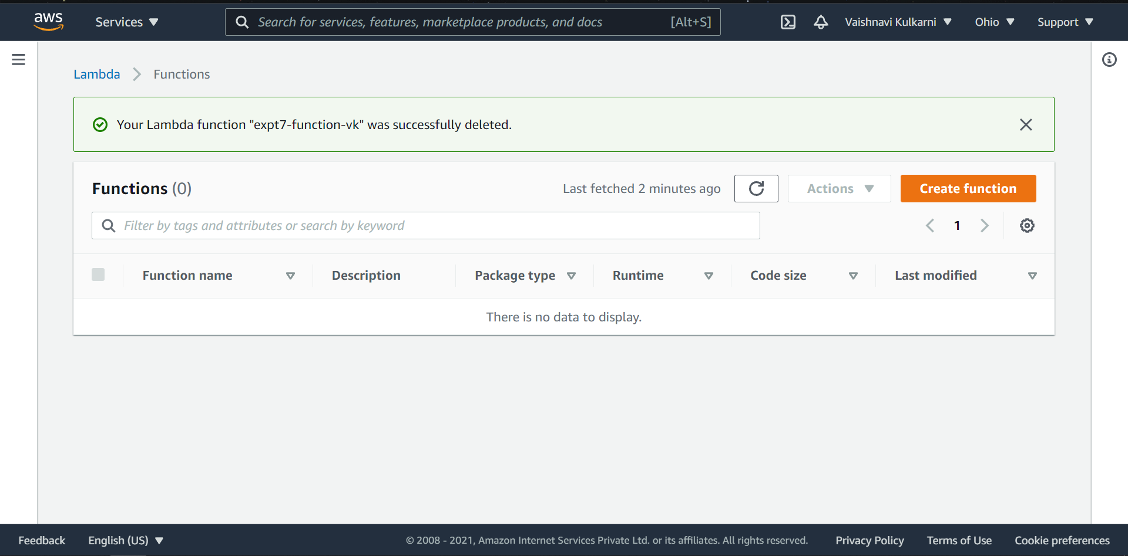

We can see the lambda function is deleted successfully

* Also, if you want you can delete the log groups of that particular function by going to CloudWatch Console

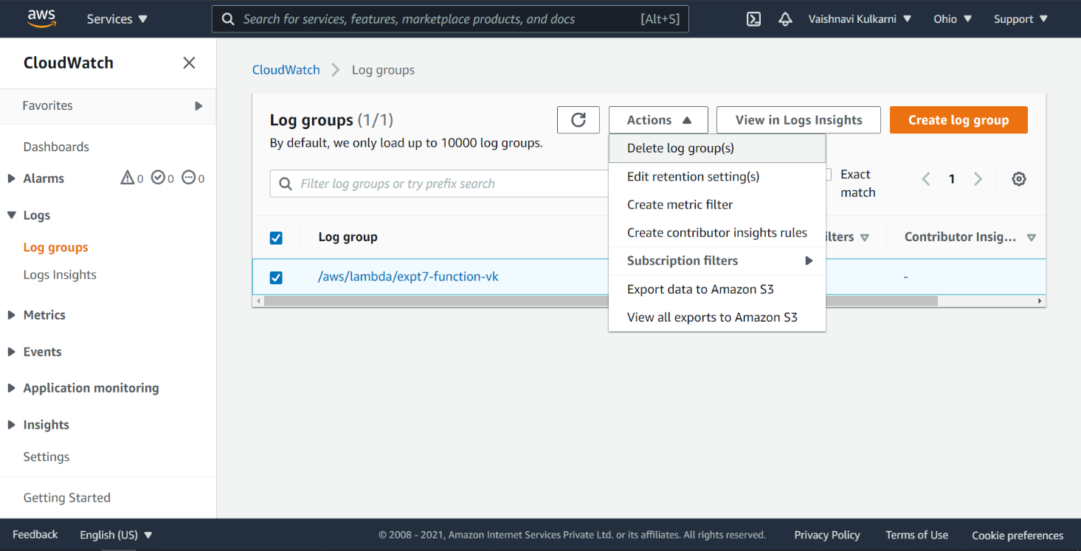

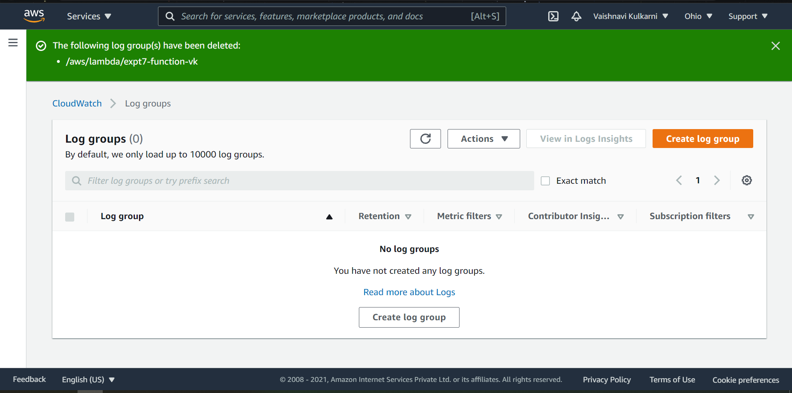

* We can test our own code using AWS Lambda by creating new function and changing the runtime of that function to python 3.9

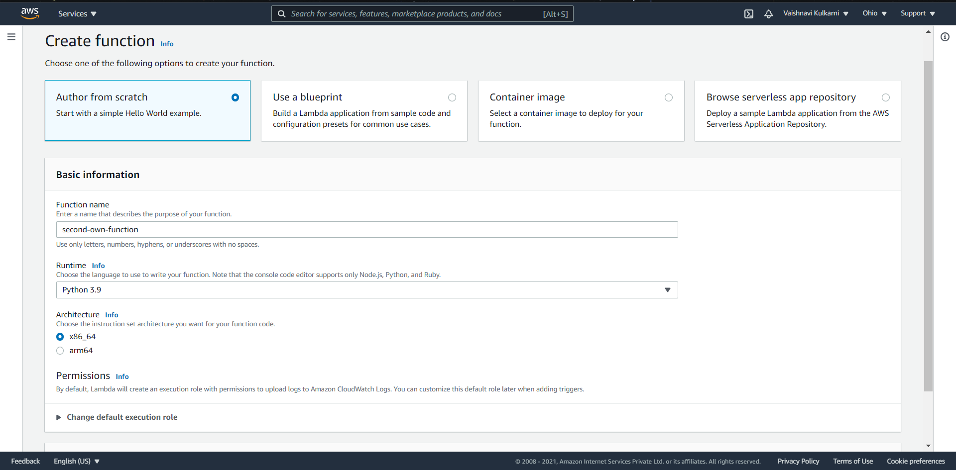

* Second function created successfully

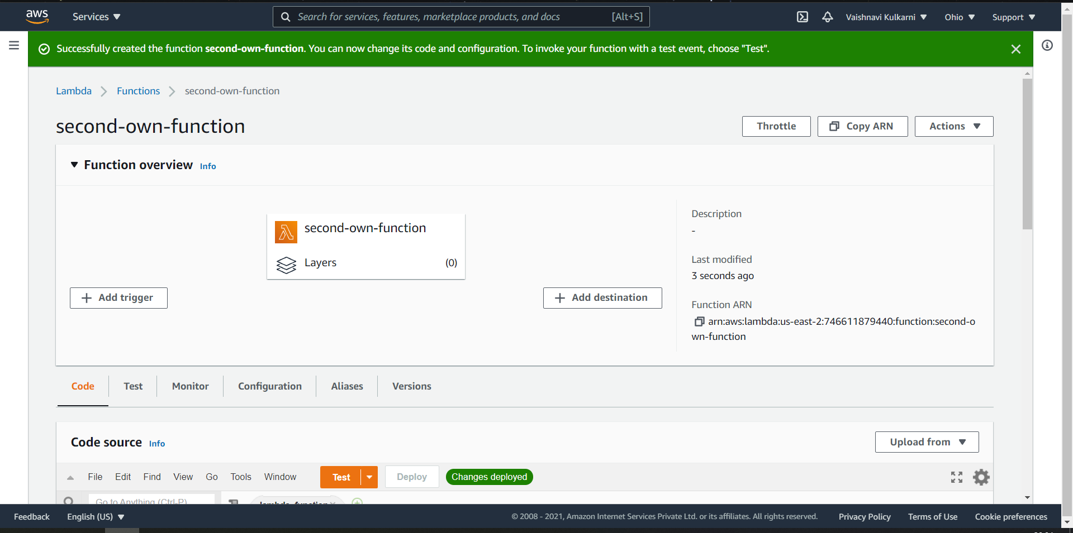

* Testing my own a simple python code

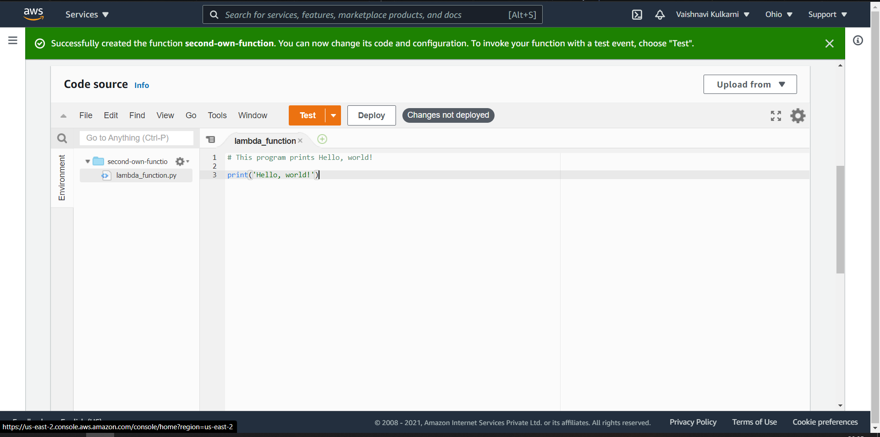

* After clicking test button enter the event name for your function

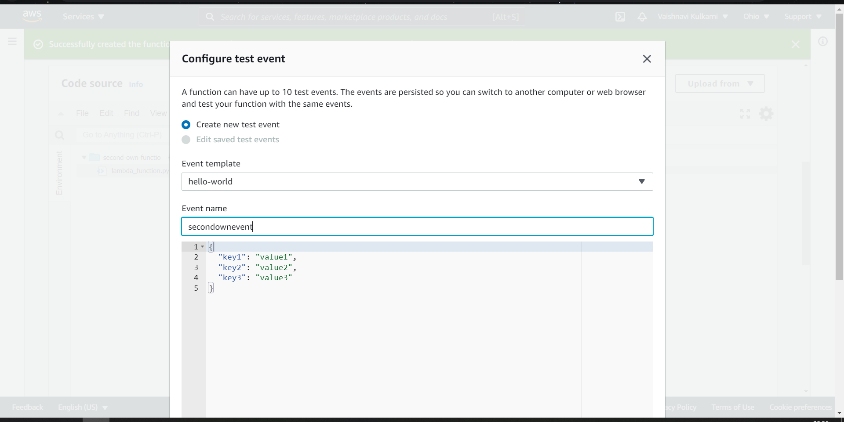s

**Conclusion:**

In this expt we created AWS Lambda Function of a specifice runtime(Nodejs) and tested it monitored it and also viewed the logs of that specific function in cloudwatch aws management console.

**Lab Outcome: ITL504.6**  
To engineer a composition of nano services using AWS Lambda and Step Functions with the Serverless Framework.